EXPERIMENTS – 1 TO 5
1.Create numeric, character, and logical vectors and display type and content.
Program:
# Numeric Vector
num <- c(5, 10, 15)
print(num)
print(typeof(num))
# Character Vector
char <- c("A", "B", "C")
print(char)
print(typeof(char))
# Logical Vector
logi <- c(TRUE, FALSE, TRUE)
print(logi)
print(typeof(logi))
OUTPUT:-
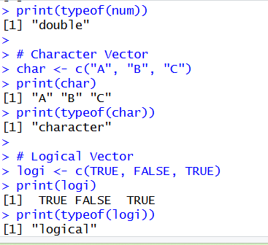

2.Create labelled matrices (5×4, 3×3, 2×2) filled by row/column.
Program:
m1 <- matrix(1:20, nrow=5, ncol=4, byrow=TRUE)
rownames(m1) <- paste("R",1:5,sep="")
colnames(m1) <- paste("C",1:4,sep="")
print(m1)
m2 <- matrix(1:9, nrow=3, ncol=3, byrow=FALSE)
rownames(m2) <- c("A","B","C")
colnames(m2) <- c("X","Y","Z")
print(m2)

m3 <- matrix(c(5,6,7,8), nrow=2, byrow=TRUE)
rownames(m3) <- c("Row1","Row2")
colnames(m3) <- c("Col1","Col2")
print(m3)

Output:-
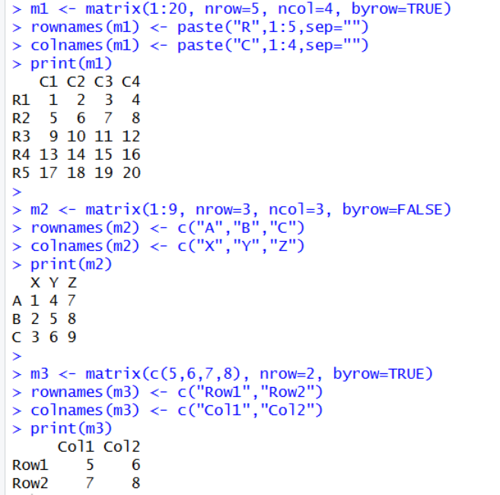
3.Write an R program to create and display a 3D array with specified rows, columns, and tables.
Program:
arr <- array(1:12, dim=c(2,3,2))
print(arr)
Output:-
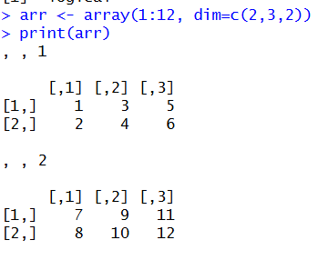

4.Create arrays from vectors with dimension names, print specific elements.
Program:
vec <- c(10,20,30,40,50,60)
arr2 <- array(vec,
dim=c(2,3),
dimnames=list(
Rows=c("R1","R2"),
Cols=c("C1","C2","C3")
))
print(arr2)
print(arr2["R2","C3"])
Output:-
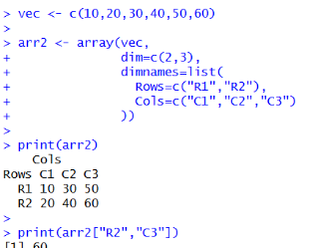
5. Create and manipulate factor variables (e.g., women’s dataset heights, random LETTERS sample).
Program:
data(women)
height_cat <- cut(women$height, breaks=3,
labels=c("Short","Medium","Tall"))
print(height_cat)
print(levels(height_cat))
set.seed(10)
letters_sample <- sample(LETTERS[1:5], 10, replace=TRUE)
letter_factor <- factor(letters_sample)
print(letter_factor)
print(levels(letter_factor))
Output:-
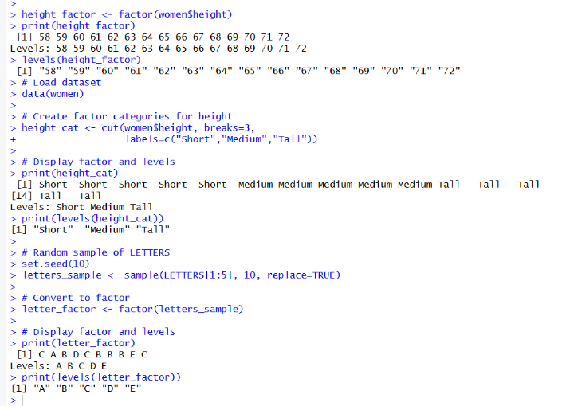

6.Create an R list containing vectors, matrices, and functions; display contents.
my_list <- list(
vector1 = c(1,2,3,4,5),
matrix1 = matrix(1:9, nrow=3),
function1 = function(x) x^2
)
print(my_list)
print(my_list$vector1)
print(my_list$matrix1)
print(my_list$function1(5))
output
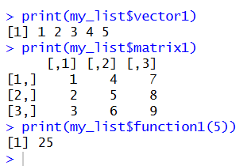
7. Write R programs for basic tasks: Factors of a number, generate a vector of 10 random integers between -50 and 50, print numbers 1–100 with FizzBuzz logic.
num <- 12
for(i in 1:num){
if(num %% i == 0){
print(i)
}
}
sample(-50:50, 10)
for(i in 1:100){
if(i %% 15 == 0) print("FizzBuzz")
else if(i %% 3 == 0) print("Fizz")
else if(i %% 5 == 0) print("Buzz")
else print(i)
}
Output
